

AP® Physics C
1975 Free Response Questions

The materials included in these files are intended for use by AP teachers for course and exam preparation in the classroom; permission for any other use must be sought from the Advanced Placement Program®. Teachers may reproduce them, in whole or in part, in limited quantities, for face-to-face teaching purposes but may not mass distribute the materials, electronically or otherwise. These materials and any copies made of them may not be resold, and the copyright notices must be retained as they appear here. This permission does not apply to any third-party copyrights contained herein.

These materials were produced by Educational Testing Service® (ETS®), which develops and administers the examinations of the Advanced Placement
Program for the College Board. The College Board and Educational Testing Service (ETS) are dedicated to the principle of equal opportunity, and their
programs, services, and employment policies are guided by that principle.

The College Board is a national nonprofit membership association dedicated to preparing, inspiring, and connecting students to college and opportunity.
Founded in 1900, the association is composed of more than 4,200 schools, colleges, universities, and other educational organizations. Each year, the
College Board serves over three million students and their parents, 22,000 high schools, and 3,500 colleges, through major programs and services in
college admission, guidance, assessment, financial aid, enrollment, and teaching and learning. Among its best-known programs are the SAT®, the
PSAT/NMSQT®, and the Advanced Placement Program® (AP®). The College Board is committed to the principles of equity and
excellence, and that commitment is embodied in all of its programs, services, activities, and concerns.

APIEL is a trademark owned by the College Entrance Examination Board. PSAT/NMSQT is a registered trademark jointly owned by the College Entrance Examination Board and the National Merit Scholarship Corporation. Educational Testing Service and ETS are registered trademarks of Educational Testing Service.
1975M1. A sphere of mass m is released from rest. As it falls, the air exerts a retarding force on the sphere that is proportional to the sphere's velocity ( F_{R} = -kv). Neglect the buoyancy force of the air.
a. On the circles below draw vectors representing the forces acting on the sphere
i. just after it is released and
ii. after it has been falling- for a long time and reached terminal velocity. Give each vector a descriptive label
(i) (ii)
b. Determine the terminal velocity of the sphere
c. Draw the following three graphs for the sphere's motion clearly showing significant features of the motion just after the sphere is released as well as after a long time.
i. Acceleration as a function of time ii. Velocity as a function of time iii. Position as a function of time.

Acceleration
Velocity
Position

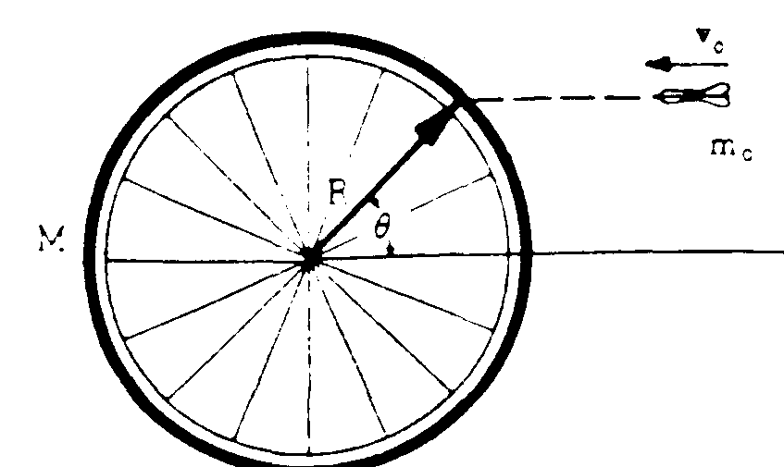
View From Above

1975M2. A bicycle wheel of mass M (assumed to be concentrated at its rim) and radius R is mounted horizontally so it may turn without friction on a vertical axle. A dart of mass m_{o} is thrown with velocity v_{o} as shown above and sticks in the tire.
a. If the wheel is initially at rest, find its angular velocity ω after the dart strikes.
b. In terms of the given quantities, determine the ratio:
final kinetic energy of the system
initial kinetic energy of the system

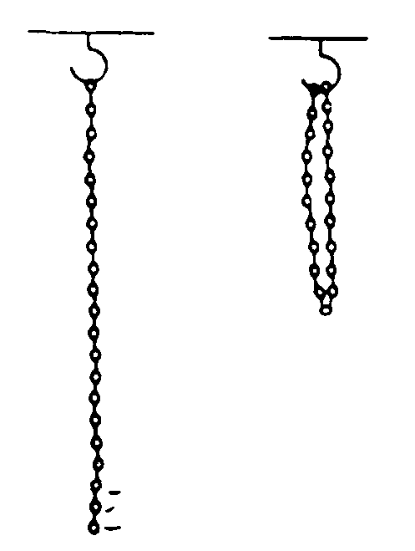
1975M3. A uniform chain of mass M and length l hangs from a hook in the ceiling. The bottom link is now raised vertically and hung on the hook as shown above on the right.

a. Determine the increase in gravitational potential energy of the chain by considering the change in position of the center of mass of the chain.
b. Write an equation for the upward external force F(y) required to lift the chain slowly as a
function of the vertical distance y.
c. Find the work done on the chain by direct integration of 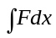.
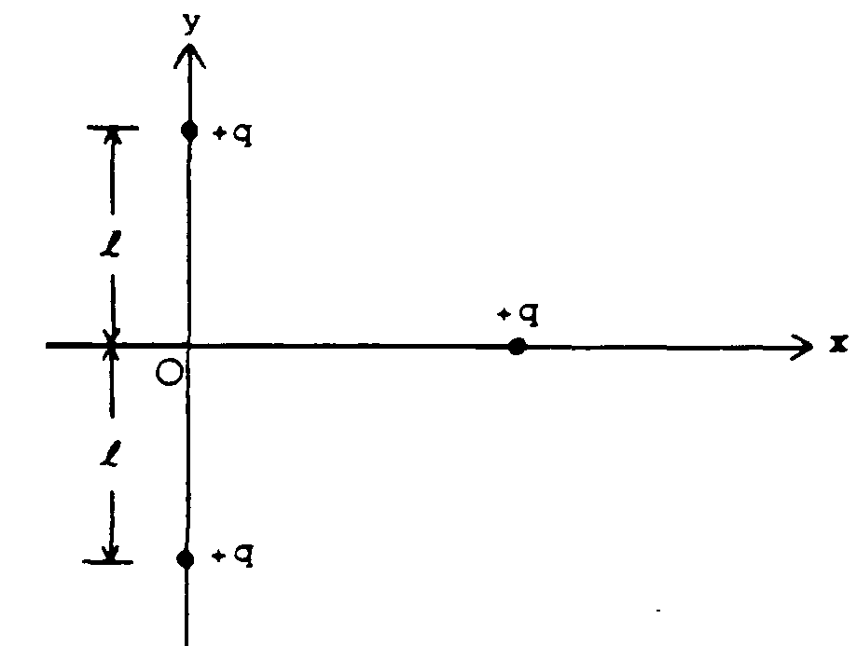

1975E1. Two stationary point charges +q are located on the y-axis as shown above. A third charge +q is brought in from infinity along the x-axis.
a. Express the potential energy of the movable charge as a function of its position on the x-axis.
b. Determine the magnitude and direction of the force acting on the movable charge when it is
located at the position x = l
c. Determine the work done by the electric field as the charge moves from infinity to the origin.

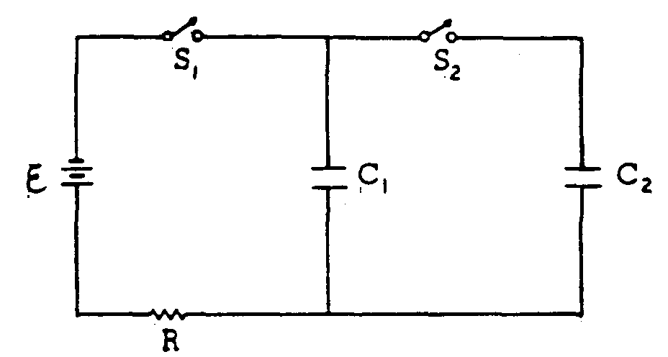
1975E2. In the diagram above, V = 100 volts; C₁ = 12 microfarads; C₂ = 24 microfarads; R = 10 ohms. Initially, C_{l} and C₂ are uncharged, and all switches are open.
a. First, switch S₁ is closed. Determine the charge on C_{l} when equilibrium is reached.
b. Next S₁ is opened and afterward S₂ is closed. Determine the charge on C₁ when equilibrium is again reached.
c. For the equilibrium condition of part (b), determine the voltage across C₁.
d. S₂ remains closed, and now S₁ is also closed. How much additional charge flows from the battery?

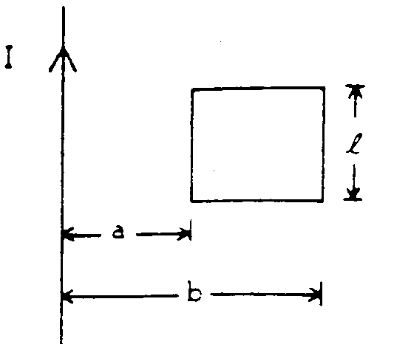
1975E3. A long straight conductor lies in the plane of a rectangular loop of wire as shown above. The total resistance of the loop is R. The current in the long straight conductor increases at a constant rate dI/dt.
a. Indicate on the diagram the direction of the induced current in the loop and explain your
reasoning.
b. Determine the magnitude of the current assuming the self-inductance of the loop may be
neglected.

